Photometry of Eclipsing binary  
[GGM2006] 3152056

M.Shaheer Niazi  
Ismael Khan

Photometry and Spectroscopy Workshop 2022 SARL

Department of Space Sciences  
Institute of Space Technology

**Table of Contents**

1.Equipment…………………………………...3

2.Photometry Target………………………......4

3.Data Acquisition…………………………….6

4.Differential Photometry……………………12

4.Results……………………………………...14

5.References………………………………….15

1. **Equipment  
     
   Telescope:** Meade 16” lx200  
   **Camera:** SBIG st402ME

**Filter:** V

**Location:** 33° 31’11” N, 73° 10’32” E

**Start of Observation:** 28/08/2022 8:42pm  
**Julian date:** 2459820.362

**Processing software:** AstroPixelProcessor

**Photometry software:** AstroimageJ

**Plotting Software:** Microsoft Excel

1. **Photometry Target**

The TESS (Transiting Exoplanet Survey Satellite) Eclipsing Binary catalogue [1] was browsed for potential candidates.

The criteria of selection was as follows:

1. Short orbital period ( < 1.5 days)
2. Magnitude ( > Mag 13)
3. Long enough visibility in the sky (stellarium was used to check positions in the sky during observation hours)

The details of the selected target are as follows:

**Name:** [GGM2006] 3152056  
**Half Period:** 0.1939254892859686 days  
**Type:** Contact  
**Morphology:** 0.769  
**Position:** RA 303.292310, Dec 62.073165

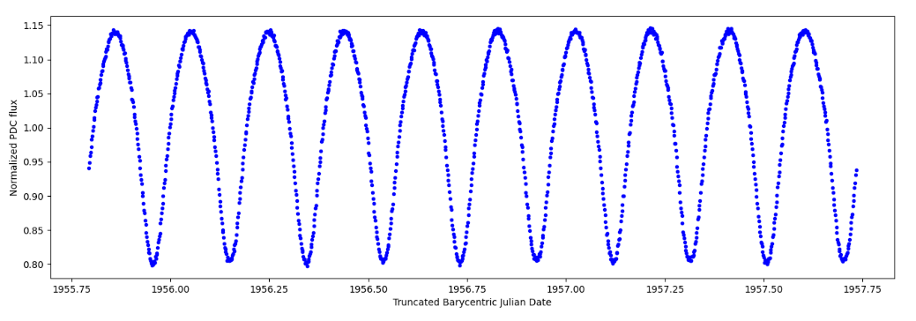The TESS light curves of the object is shown below. [2]  
  
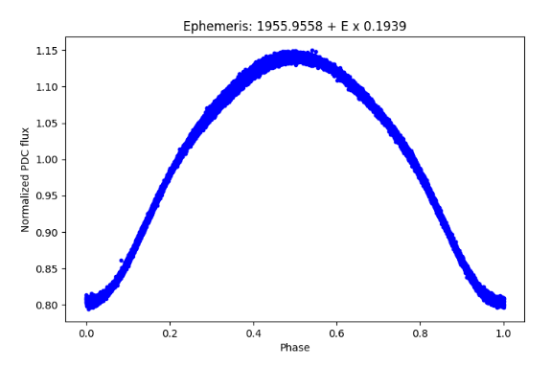

Note: phase of 1.0 on the TESS data is equivalent to a half orbit

**3. Data Acquisition**

**Exposure time:** 15 s  
**Total frames:** 3426  
**Total Data:** 14.275 hr

The data was captured over three nights,

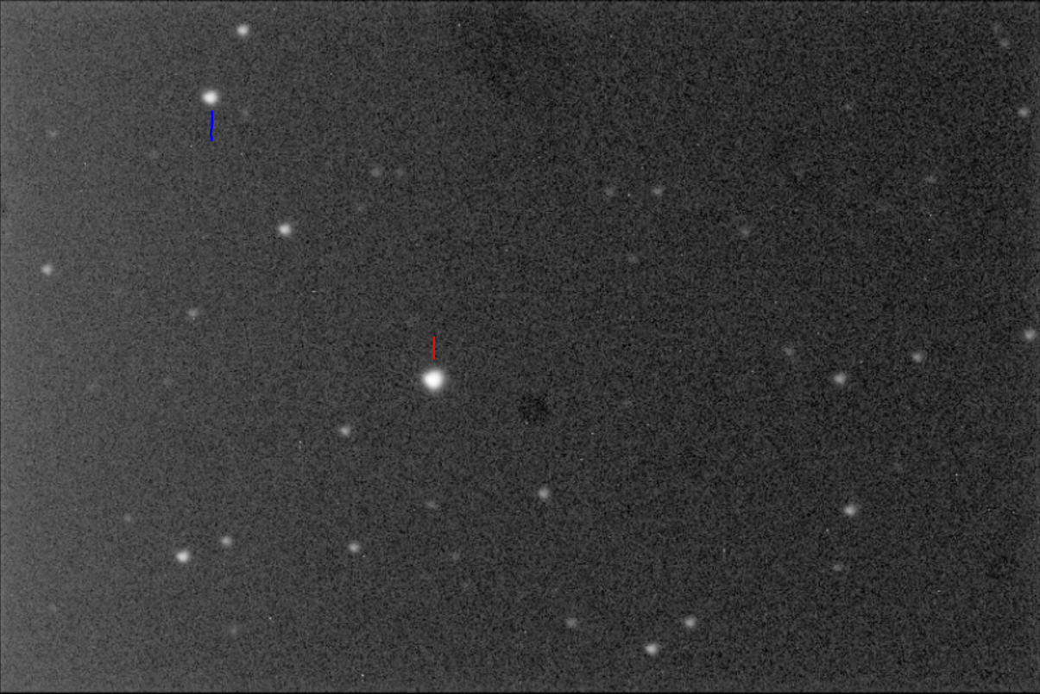The 28th, 29th and 31st of September 2022.  
*figure 3. Single frame of the target (red). The star marked with blue is the reference star.*

The images were all loaded into Astro Pixel Processor for:

1. Calibration:  
   Removal of noise, gradients and dust.
2. Registration:  
   Alignment of frames.
3. Normalization:  
   Normalizing the background brightness of each frame.

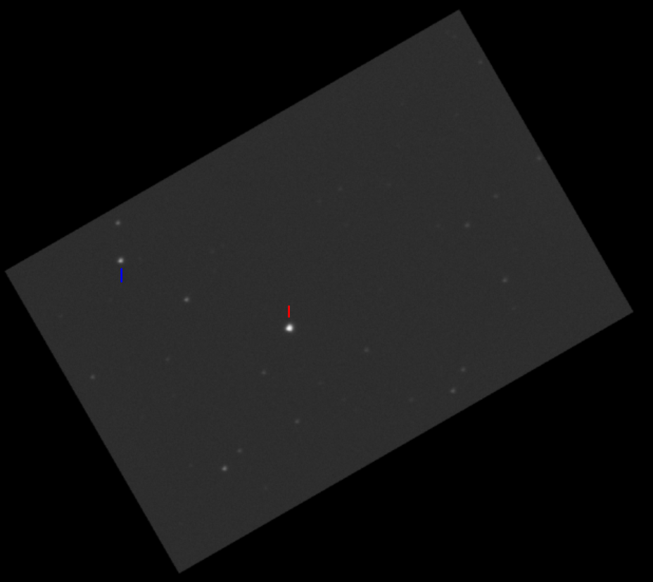Here’s an example of a processed frame:

*Figure 4: The frame from fig.3 after processing. Red is our target star and blue is the reference.*

**Processing images**

**Calibration**There are three types of calibration frames taken along with the data.

1. **Darks:** Dark images are taken at the same exposure as the data images (lights) but with the shutter covered. We essentially capture the noise and hot pixels due to the camera sensor.
2. **Flats:** Flats are images taken against a uniformly bright flat surface. Doing so helps to bring out dust particles and lens gradients in the images. Flats must be taken so that their histogram peak is slightly to the left of the center and not being clipped at any end.
3. **Bias:** Bias images are taken at the faster shutter speed of the camera with the shutter closed. Sensor related noise and artifacts are captured.

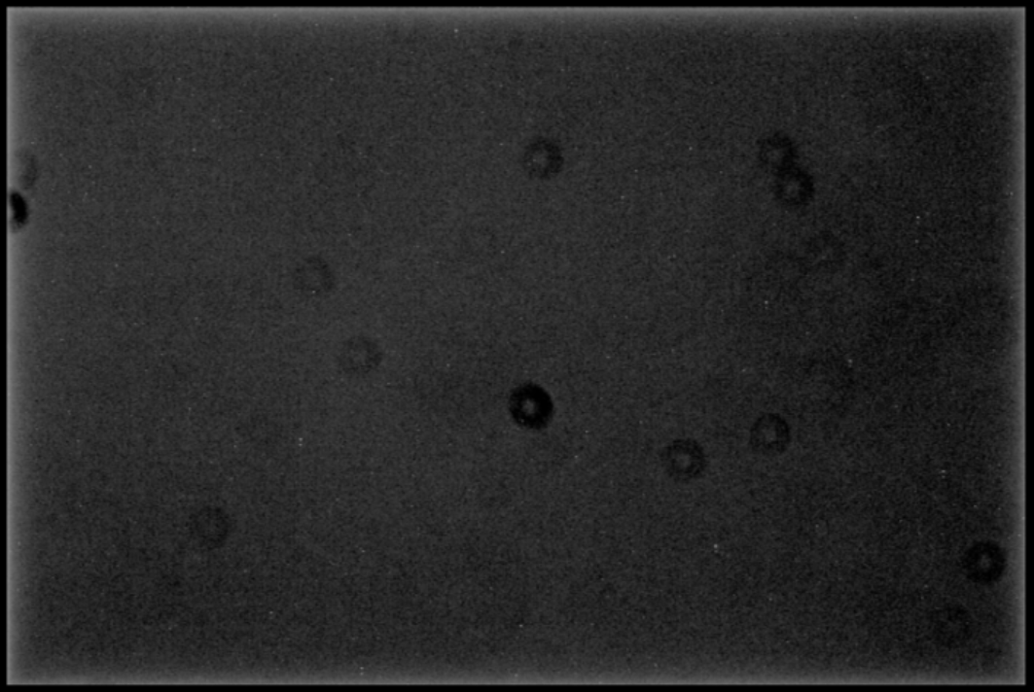  
*Sample flat. The dark rings are dust particles.*

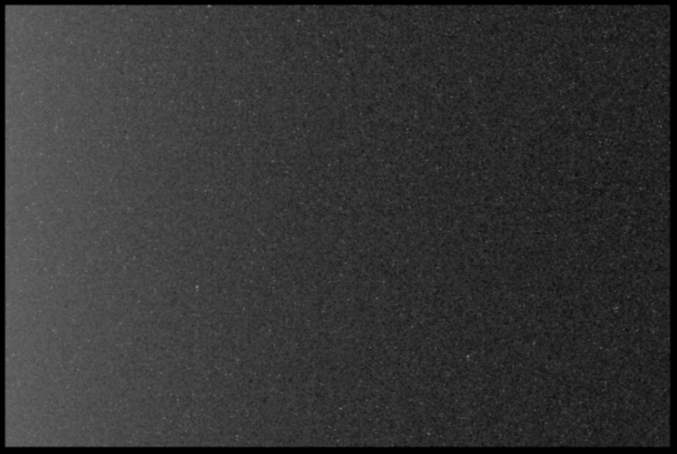

*Sample dark. Linear sensor gradient is visible, which is intrinsic to CCDs. The white pixels are hot pixels.*

When loading in the data frames, the calibration frames are loaded in alongside. In the stacking process, the calibration master frames(stacks) are subtracted from the data.

**Registering**

In Astropixelprocessor an automatic registration algorithm is selected according to preset conditions and the loaded data. Star analysis is performed to locate stars and create coordinates for them in each image. The process fails if there are too little stars detected. Stars need to be round to count in the detection. Trailed stars will fail the process.

A quality score is generated of each frame according to how round the detected stars are and how many are detected. The highest quality frame is chosen as a reference frame for the next process.

**Alignment**

Using the detected stars in each image, the software fits each image onto the reference frame according to where each star should be. This aligns all the frames according to the reference and is crucial for stacking. Interpolation is used for alignment.

**Normalization**

Using mean and standard deviations, the spread of pixel values in each image is made equal so that they can be comparable to each other. Background brightness is equalized in the process.

**4.Differential Photometry**

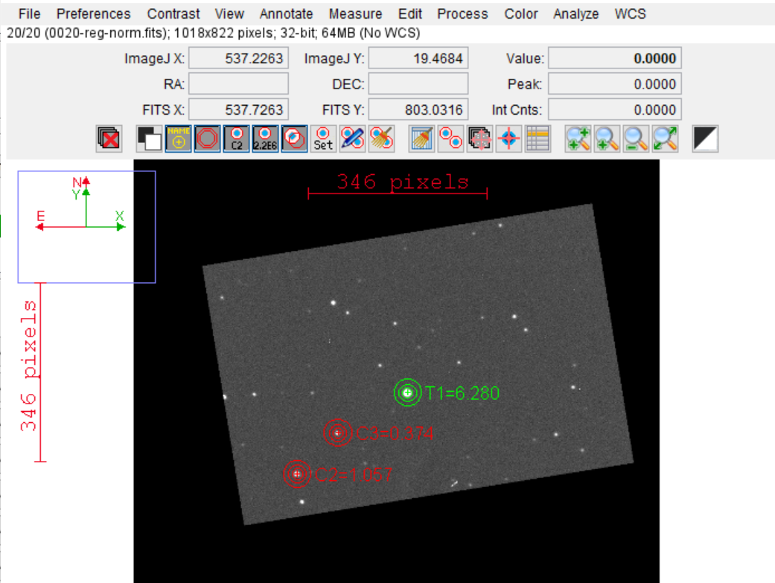The calibrated images were imported into AstroimageJ to perform differential photometry on and acquire the light curve.

*Figure 5: Astroimage J window with images imported.*

Multi aperture photometry is selected to analyze the relative flux of the target star with reference to one or more reference stars, whose flux is not variable.

In figure 4 we can see the green aperture (circles) on our target star. This is T1, the reference stars are marked in the red apertures as C2, C3. The flux inside the aperture is measured and subtracted from a background reading.

The software analyses the flux in each frame and uses the following formula to calculate a relative flux. [3]

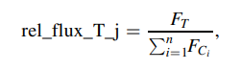

Where is the flux of the target in each frame and is the flux of each reference star summed. The ratio is the relative flux. To read more about the workings of AstroimageJ, refer to reference number [3].

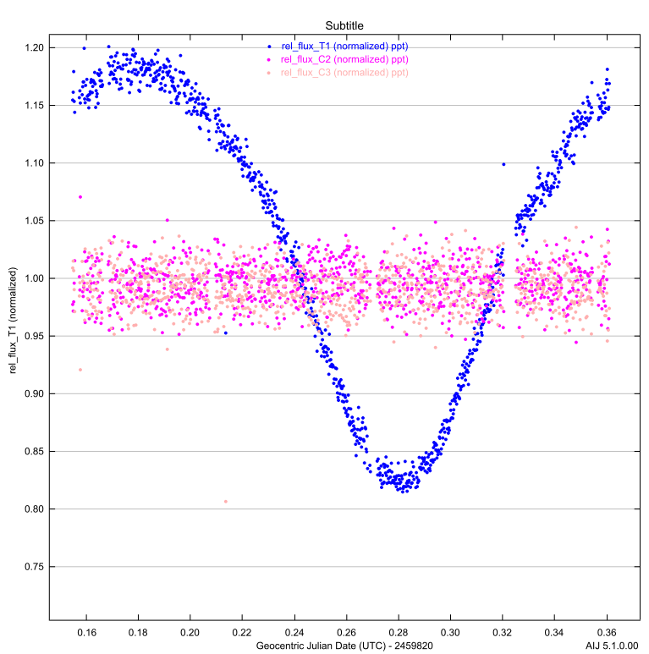**5.Results**each relative flux value is then plotted on a graph vs time. With this we end up with our light curve for our target.

*Figure 6: light curve plotted from data by AstroimageJ.*

In the plot, the blue curve is of our target star, showing an eclipse taking place, causing a dip in brightness. The data in magenta and peach are the relative fluxes of the reference stars, which are constant.

This marked the end of the workshop session on photometry of eclipsing binaries.

**6.References**

**[1] TESS Eclipsing binary catalogue, live database,** [**http://tessebs.villanova.edu/**](http://tessebs.villanova.edu/)

**[2] [GGM2006] 3152056 TESS entry,** [**http://tessebs.villanova.edu/0236884425**](http://tessebs.villanova.edu/0236884425)

# [3]. ASTROIMAGEJ: IMAGE PROCESSING AND PHOTOMETRIC EXTRACTION FOR ULTRA-PRECISE ASTRONOMICAL LIGHT CURVES, Karen A. Collines et.al. 2017, https://iopscience.iop.org/article/10.3847/1538-3881/153/2/77